REVIEW 02

Use Case Diagram.

Use Case for Customer
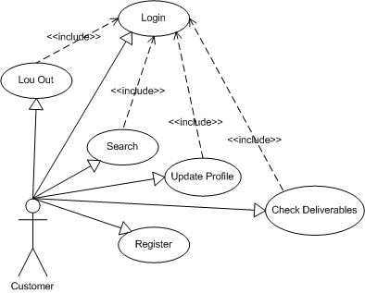

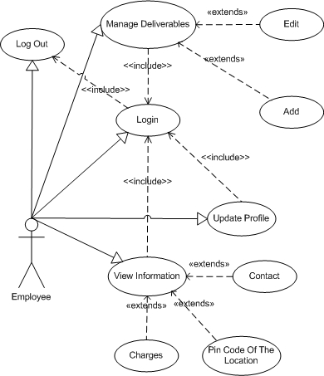
Use Case for Employee

Use Case for Admin
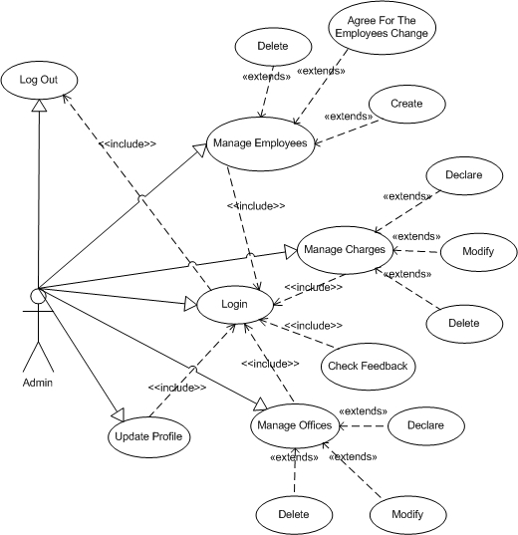

Use Case Description.
keke

Class Diagram.

Sequence Diagram.

Entity Relationship Diagram (EFD).

Entity Description.

BRANCHE
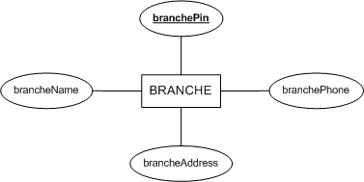

OFFICE
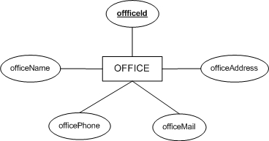

ROLES
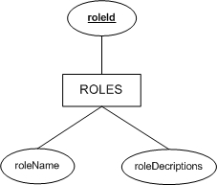

EMPLOYEE
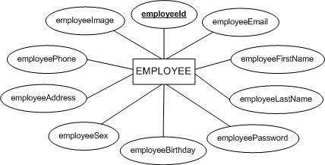

CUSTOMER
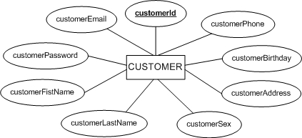

DELIVERABLE
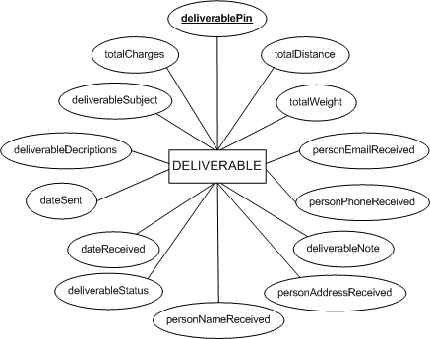

SERVICETYPE
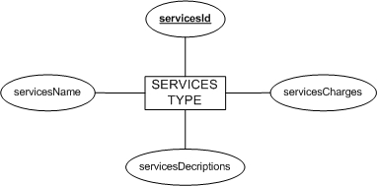

CHARGES_ON_WEIGHT
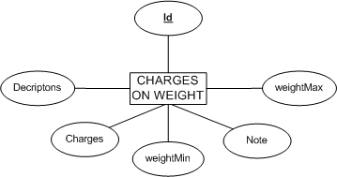

CHARGES_ON_DISTANCE
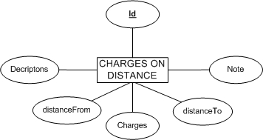

Table Design.

BRANCHE
No | Column Name | Data Type | Size | Check | Description
1 | branchePin | varchar | 10 | Not Null
2 | brancheName | varchar | 50 | Not Null
3 | brancheAddress | varchar | 250 | Null
4 | branchePhone | varchar | 20 | Null

OFFICE
No | Column Name | Data Type | Size | Check | Description
1 | offficeId | varchar | 10 | Not Null
2 | officeName | varchar | 50 | Not Null
3 | officeAddress | varchar | 250 | Not Null
4 | officePhone | varchar | 20 | Not Null
5 | officeMail | varchar | 50 | Not Null
6 | branchePin | varchar | 10 | Not Null

ROLE
No | Column Name | Data Type | Size | Check | Description
1 |  roleId | varchar | 20 | Not Null
2 | roleName | varchar | 50 | Not Null
3 | roleDecriptions | varchar | 250 | Null

EMPLOYEE
No | Column Name | Data Type | Size | Check | Description
1 |  employeeId | varchar | 10 | Not Null
2 | employeeEmail | varchar | 50 | Not Null
3 | employeePassword | varchar | 50 | Not Null
4 | employeeFirstName | varchar | 50 | Not Null
5 | employeeLastName | varchar | 50 | Not Null
6 | employeeBirthday | datetime |  | Not Null
7 | employeeSex | bit |  | Not Null
8 | employeeAddress | varchar | 250 | Not Null
9 | employeePhone | varchar | 20 | Null
10 | employeeImage | varchar | 50 | Null
11 | offficeId | varchar | 10 | Not Null
12 | roleId | varchar | 10 | Not Null

CUSTOMER
No | Column Name | Data Type | Size | Check | Description
1 |  customerId | varchar | 10 | Not Null
2 | customerEmail | varchar | 50 | Not Null
3 | customerPassword | varchar | 50 | Not Null
4 | customerFistName | varchar | 50 | Not Null
5 | customerLastName | varchar | 50 | Not Null
6 | customerBirthday | datetime |  | Null
7 | customerSex | bit |  | Null
8 | customerAddress | varchar | 250 | Not Null
9 | customerPhone | varchar | 20 | Null
10 | roleId | varchar | 10 | Not Null

SERVICESTYPE
No | Column Name | Data Type | Size | Check | Description
1 |  servicesId | varchar | 10 | Not Null
2 | servicesName | varchar | 50 | Not Null
3 | servicesDecriptions | varchar | 250 | Null
4 | servicesCharges | float |  | Not Null

DELIVERABLE
No | Column Name | Data Type | Size | Check | Description
1 | deliverablePin | varchar | 10 | Not Null
2 | customerSent | varchar | 10 | Not Null
3 | deliverableSubject | varchar | 50 | Not Null
4 | deliverableDecriptions | varchar | 250 | Null
5 | dateSent | datetime |  | Not Null
6 | dateReceived | datetime |  | Null
7 | personNameReceived | varchar | 50 | Not Null
8 | personAddressReceived | varchar | 250 | Not Null
9 | personPhoneReceived | varchar | 20 | Null
10 | personEmailReceived | varchar | 50 | Null
11 | totalWeight | float |  | Not Null
12 | totalDistance | float |  | Not Null
13 | totalCharges | float |  | Not Null
14 | deliverableStatus | bit |  | Not Null
15 | deliverableNote | varchar | 250 | Null
16 | servicesType | varchar | 10 | Not Null
17 | employeeId | varchar | 10 | Not Null

DELIVERABLE_DETAIL
No | Column Name | Data Type | Size | Check | Description
1 |  detailId | varchar | 10 | Not Null
2 | deliverablePin | varchar | 10 | Not Null
3 | deliverableName | varchar | 50 | Not Null
4 | deivrableWeight | float |  | Not Null
5 | Decriptions | varchar | 250 | Null
6 | Note | varchar | 250 | Null

CHARGES_ON_WEIGHT
No | Column Name | Data Type | Size | Check | Description
1 |  Id | varchar | 10 | Not Null
2 | Decriptons | varchar | 250 | Not Null
3 | weightMin | float |  | Not Null
4 | weightMax | float |  | Not Null
5 | Charges | float |  | Not Null
6 | Note | varchar | 10 | Null
7 | servicesType | varchar | 10 | Not Null

CHARGES_ON_DISTANCE
No | Column Name | Data Type | Size | Check | Description
1 |  Id | varchar | 10 | Not Null
2 | Decriptons | varchar | 250 | Not Null
3 | distanceFrom | float |  | Null
4 | distanceTo | float |  | Null
5 | Charges | float
6 | Note | varchar | 250
7 | servicesType | varchar | 10

FEEDBACK_AND_CONTACT
No | Column Name | Data Type | Size | Check | Description
1 |  Id | varchar | 10 | Not Null
2 | Name | varchar | 50 | Not Null
3 | Email | varchar | 50 | Not Null
4 | Address | varchar | 250 | Not Null
5 | Phone | varchar | 20 | Null
6 | Subject | varchar | 50 | Not Null
7 | Contend | varchar | 250 | Not Null
8 | datesubmit | date |  | Not Null
9 | status | bit |  | Not Null

COUNT_VISIT
No | Column Name | Data Type | Size | Check | Description
1 | count | int |  | Not Null

Table Relationship Diagram.

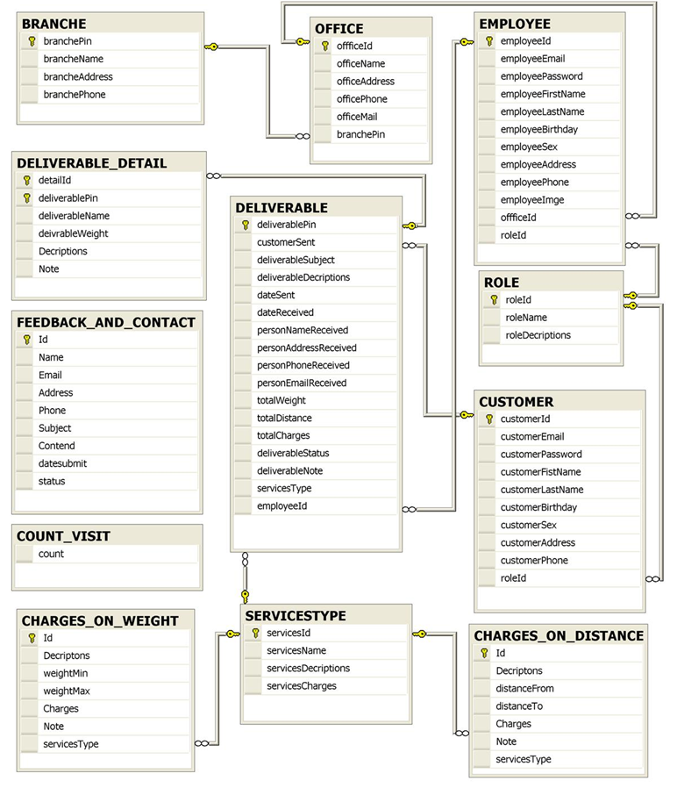

TASK SHEET REVIEW 2

Project  Ref. No. |  | Project title | Activity Plan | Date of Preparation of Activity Plan
Sr. No | Task | Description | Planed Start Date | Actual Start Date | Actual Days | Team Mate Name | Status
1. | REVIEW-02 |  | 22-May-2010 | 22-May-2010
2 | REVIEW-02
3 | REVIEW-02
4 | REVIEW-02
5 | REVIEW-02
6 | REVIEW-02

